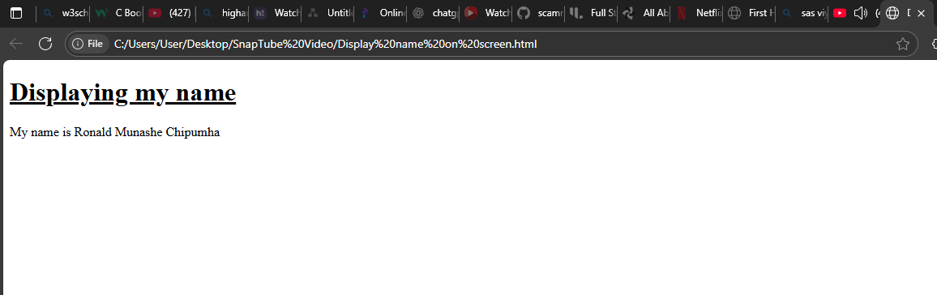
<!DOCTYPE html>
<html>
<head><title>Displaying name on screen</title></head>

<h1><u>Displaying my name</u></h1>
<body>
<p>My name is Ronald Munashe Chipumha </p>
</body>

</html>

